URMSTON PRIMARY SCHOOL

Dear Parents/Carers,

Y1 VISIT TO SALE WATERSIDE THEATRE TO SEE
“MR POPPER’S PENGUINS”

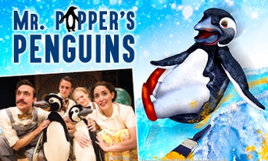
A visit to the Sale Waterside has been organised for the Y1 children in classes 1, 4 and 5 on TUESDAY 3RD DECEMBER to watch the delightful, action packed musical adaptation of Richard and Florence Atwater's popular book “MR POPPER’S PENGUINS”.

The musical will be during school time and we have arranged for the pupils, staff and helpers to travel by a coach fitted with seatbelts, leaving school in the morning for a 10.30am performance. If you or another relative is free on the morning of the 3rd December and would be able to volunteer your time to provide additional support for our staff, please complete the slip below and return it to school ASAP, and by Tuesday 26th November at the latest, so that we can draw names from a hat in the event of too many offers.
On this occasion the PTA have agreed to pay the total cost of the coach, which amounts to £350. Without their contribution this visit would probably be too expensive for us to consider. We are therefore extremely grateful for their support.

The cost of the theatre ticket will be £10.00 per child, which is the school price for matinees and is non-refundable, which we ask you to pay via ParentPay. We think this is a wonderful opportunity for the Year 1 children to enjoy this special performance with their friends.

If you DO NOT wish your child to take part in the visit, please let the school office know as soon as possible.

Yours faithfully,

Simon Parker
Headteacher

____________________________________________________________

Child’s Name ___________________________________ Class ________

I can help and accompany the children to Sale Waterside:

Name__________________________________________________

