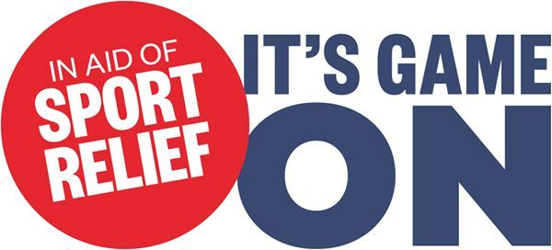

Dear Parents/Carers,
Next Friday 13th March, Urmston Primary School will be taking part in a Skittleball challenge to raise money in aid of Sport Relief. Two years ago, we ran 1000 miles and this time around, we are going to be taking part in an all-day Skittleball match. Teachers, pupils and hopefully some of you parents and carers will keep two marathon games going from 8.30am to 3.30pm. It’s game on between our two mega teams managed by our two sponsored Amur Leopards, Happy and Larry.
On one side will be Happy’s Heroes and on the other will be Larry’s Legends in an almighty battle to be crowned Urmston Primary’s Skittleball champions.
We understand that there are lots of demands on sponsorship etc. so please don’t feel the need to collect vast sums of money, even £1 per child would help us collect a significant amount for this worthy cause.
We hope that you can help support us on Friday next and if you would like to join in the game, please come along at 3.00 and we will find you a place on the team! (We will have a game going on in both the Infant and Junior playgrounds.)
Thanks for your support in all we do.
Kind regards,
UPS Staff and children

