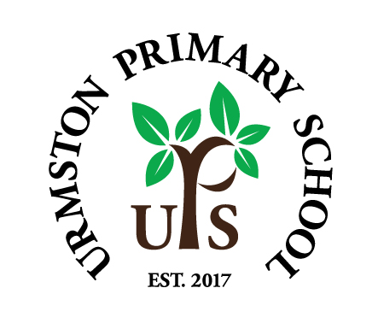
Friday 24th January 2020
Dear Parents/Carers,

Have a happy Chinese New Year everyone. The year of the rat is upon us.Rats are clever, quick thinkers; successful, but content with living a quiet and peaceful life. May you all have these attributes, should you so wish! ;-)

PTA Pre-loved fancy dress costume sale (and uniforms!)…for World Book Day
The PTA will be holding a sale and breakfast on Friday 21st February at 8.15. If you have any costumes or pre-loved uniforms you might like to donate, then please bring them to the office by the 20th February. They will be on sale for just £1 each!

PTA Valentines Disco
This takes place on Thursday 6th February between 5.30pm and 7.30pm. We still need more volunteers, so please return your slip if you can help out.

Parent contacts and workshops – looking after ourselves
There are a number of agencies in our local authority that offer support for families who need it. Attached with this email is a zip file of a number of contact details and workshops that may be of interest. These include Blusci support for mental health and wellbeing, NAS autism seminars, Just Psychology Mental Health and Wellbeing support, R-Space support for domestic abuse, IATP’s Trust Fall project and ROC community mentors. You’ll also find these details on our Wellbeing and Pastoral Care page on our website, under the Information tab.

Urmston Manor…we’ll keep this on!
Our super children continue to show their kindness and respect when they visit Urmston Manor Residential Home on Thursdays. It was J8’s turn this week and the feedback from the children and residents is, as always, both heartwarming and pride-provoking (if we can use such a term!). Thanks to all involved.

Homework
We’ve had some more comments and ideas from parents regarding our recent question. Staff will be discussing these and we’ll see how this might look and the expectations for the next half term. Thanks for your involvement.

KS1 English Workshop
…will most likely be the second or third week back after half term. We’ll let you know!

Come on everyone…let’s build our alumni community
Let’s keep this going…we are really building here and would love to develop this project in collaboration with the education charity, Future First. It involves building a community of former pupils (and even friends of those former pupils) who are willing to forge closer links with our school and perhaps be on hand to help us out and inspire our children in all manner of ways. So please get talking – sign up yourself and ask others to sign up on our online portal…the opportunities are endless! Thank you and here is the link (and there’s a poster too below…let’s watch our community grow!
https://networks.futurefirst.org.uk/signup/urmstonprimary

Science ‘Question of the Week’
Last week’s question was ‘How are snowflakes formed?’ Your junior children may well now know the answer! This week’s question is ‘How big is the earth compared to our solar system, galaxy and the whole univserse?’ Please do talk to your children about this and help to further enhance their curiosity in the world around them!

Continuing with E-Safety
Keep an eye out for our monthly newsletter which hopefully will help with some valuable information on current apps, games and E-safety issues that your child (and us adults!) need help with. January’s issue will be emailed to you.

Have a lovely weekend!

Kind Regards,

Mr Parker and Mr Doherty

