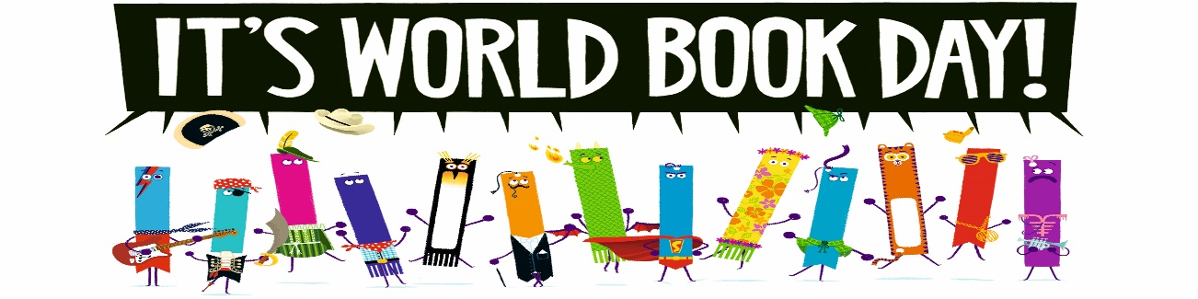
World Book Day – Thursday 5th March 2020 Events for the day
Dear Parents and Carers,
With World Book Day fast approaching, I would like to take this opportunity to share with you the events for the day and activities that we will be participating in, in the lead up to the day.

Before the day
As a school, we are taking part in the World Book Day theme of ‘Share a Million Stories’. Your child has attended an assembly explaining this and I have attached the sheet as well for you to enjoy marking down every time you share a story for 10 minutes. We will then collect all these sheets in and add up the total time for all pupils, with prizes for the most amount of time spent reading and a certificate for every child who has taken part.
Share a Million Stories runs throughout World Book Day month, from 27 February-29 March.
Dressing up
As always, we ask that children dress up as a character from a book, or simply bring in prop. There is no expectation for parents to rush out and buy a costume – often homemade ideas are the best anyway! We also ask, that your child brings the book relating to that character or theme if they have it.
Book Quotes
In each hall, we will have quote boards. We are asking the children to add a quote or extract to our board from the book of the character they have dressed up as.
Book Swap
Before school, we will be holding a book swap in each of our halls at 8:30 onwards. This is an opportunity for children to bring in a book from home that they have already read and exchange it for another. We will not be asking for the books to be wrapped this year, but jut to simply being it in, add it to one of the tables and choose another book that takes their fancy. Parents are invited to stay and share the book with their child. We will not have a drop off facility, as the event is being hosted by our Year 6 librarians, so adults must stay with their child.
Throughout the day
This year, as a school we will be using the book ‘Lost Words’ by Robert Macfarlane and Jackie Morris, which incorporates the themes of nature and language. Each class will take part in a variety of activities throughout the day, culminating in displays of their fabulous achievements.
The children will also have the opportunity to take part in master classes online from famous authors.
Parade
At 10:45am, the pupils will have a chance to show off their costumes in a school parade. This will not be open to parents, but simply a chance for the entire school to come together to celebrate the wonderful world of books.
Book tokens
A usual, your child will receive a book token for £1, which they may use at Urmston Book Shop, Sainsbury’s, or any other participating book shop to either purchase one of the titles for £1, or put towards another book of their choosing.

Although this is a fun day, we want to ensure that the purpose is not lost behind the costumes. Reading is key, both to gain knowledge and for entertainment. We hope that you will continue to support us in ensuring that every child not only gains the essential skills of reading, but also fosters a love for books and a thirst for knowledge.

Many Thanks
Mrs Hall
English Lead

