Urmston Primary School

PE & Sports Premium Report July 2019

For the financial breakdown of Sports Income & Expenditure, please see Excel spreadsheet on UPS website.

PE & Sports Premium 2018-19

The Government gives PE & Sports Premium Funding to all schools in the country which is to be ring-fenced and can only be used to improve PE through coaching and offering multiple sports provision. UPS' allocation for 2018-19 is £20 160 and is based on an amount of £16 000 plus £10 per pupil in years 1 to 6.
It is received in two payments : 7/12 of the funding is allocated on 31st October 2018 and the balance of 5/12 on 30th April 2019.

History

Urmston Primary School was established in 2017 following the merger of Urmston Infants and Junior Schools.
As a result, the Sports Premium received for the academic year 2018-19 is a single premium. Although the premium available to schools has nearly doubled from that in previous years, effectively our premium remains the same : a single school as opposed to separate Infants and Juniors which each received their own premiums in previous years.

Sports Ethos

Sport is, and always has been, a vital component in the day-to-day lives of our students. We have always emphasised the importance of an active lifestyle, in terms of its physical but also the mental benefits and feelings of well-being. Children exercising and playing team sports develops their self-esteem, social skills and improves their "thinking skills" and "alertness" ready for their lessons.
As well as a thorough PE curriculum, physical activity is encouraged in other areas of the curriculum : being used in Maths (Maths of the Day/Active Maths), in PSHE (the social/mental benefits of sport) and in general classroom activity (such as Five-a-Day and GoNoodle dance and movement activities).
Dance activities have been used to support curriculum and topic learning.
We have held a number of whole-school assemblies to showcase sports which have resulted in extra-curricular clubs, such as fencing and judo.
Furthermore, class teachers are encouraged to take their classes out onto our Daily Mile course if they feel that a spell of physical activity will boost the childrens' brainpower and focus in class. Indeed, this happens on an encouragingly regular basis !
We also endeavour to use our school twitter page to promote as many of our sporting / physical initiatives as possible.

Sports Provision

Urmston Infants and Juniors have historically had close links with external providers to supply sporting activities to our pupils.
This year, UPS decided to rationalise previous sports providers and appointed PE & Sports Hub (PESH) for extra-curriculum sports and an element of curriculum-based PE. However, this wash as much to further train staff in PE provision as well as in usage of PESH's assessment app, the PE Passport. We are mindful that, as of 2020, no external provider can be used to take the PE curriculum. Traditionally, KS2 staff have always taken their own PE lessons and we feel that, by 2020, all staff will be 100% confident and competent in taking their own lessons.

Timetable / Meeting the Requirements

At UPS, each class has a one-hour indoor and one-hour outdoor PE session (weather permitting!) in their timetable each week. In addition, we make use of the Daily Mile track that we installed around our combined playgrounds in 2017. Staff have a timetable where they can lead the children in additional running / walking around our track at break times (morning / afternoon) as well as lunchtimes. Therefore, we are confident that our children receive their statutory 60 minutes PE during each week at school, before our extra-curricular activities come into play.

Festivals Attended 2018-19

Trafford Schools Swimming Gala at Urmston Leisure Centre
Football at Manchester United Foundation at MUFC's Cliff Training Ground (separate dates for boys and girls events)
Boys and Girls Football Competitions at Davyhulme Primary
Trafford Schools Kwik Cricket Competition at Stretford Cricket Club (May 2019)
Urmston Schools Tennis competition at Urmston Sports Club (June 2019)
The Tim Sutton Commemorative Football competition for Year 5s at Davyhulme Primary School (June 2019) where our 'C' team represented the school.

Achievements

Obviously, we encourage our children to become active and enjoy as many sporting competitions as they can, regardless of the outcome. However, it is always great to actually win some of these competitions (remembering the timeless advice to lose with grace and win with humility !)
Our pupils have represented the school in a number of such competitions such as the Trafford football league and cup competitions, baseball and netball friendlies against local schools etc.
However, it is with pride that I can report that UPS were winners in the following :

* Kwik Cricket competition at Stretford Cricket Club in June against Urmston and Stretford-based schools. Our mixed team of Years 5 and 6s won all their games in a mini-league, then knockout basis to raise the winner's trophy. Unfortunately they were unable to represent the area in the later North-West finals as the date clashed with Transition Days for our Year 6s.

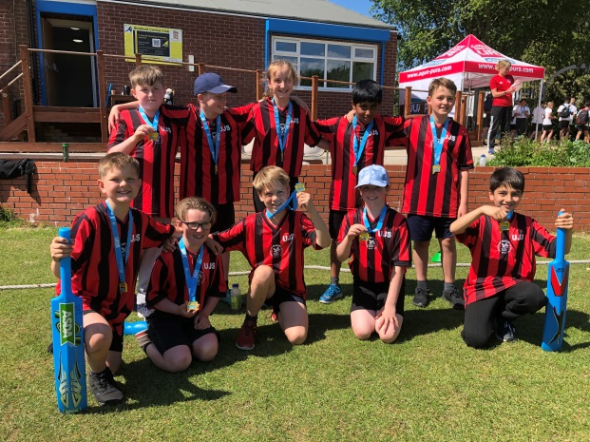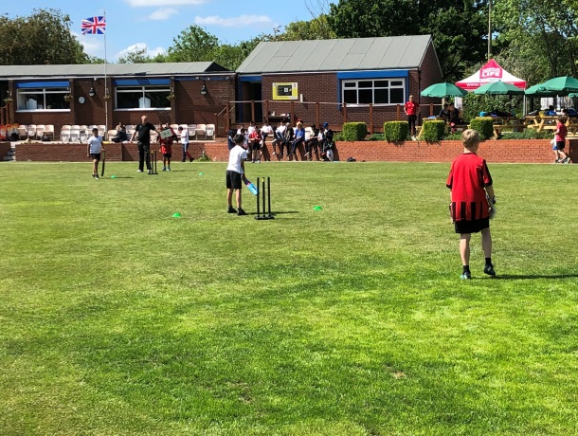

* Hi-5 Netball competition at Flixton Girls' School in March. Another mixed team (gender, age) won their competition against other Urmston-based schools, progressing to a Trafford-wide competition where they actually finished 4th!

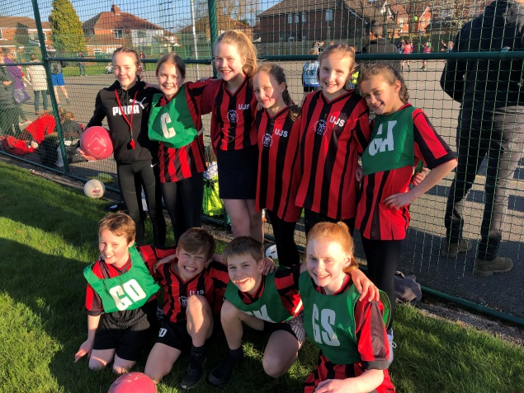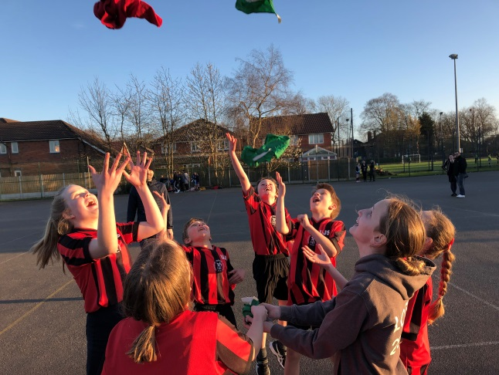

* Tennis. We entered 3 teams into the event held at Urmston Sports Club, with one of our teams of Year 5/6 players coming top of the whole event (for the second year in a row!)

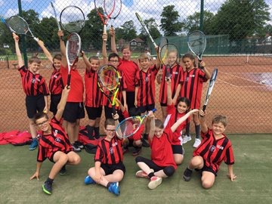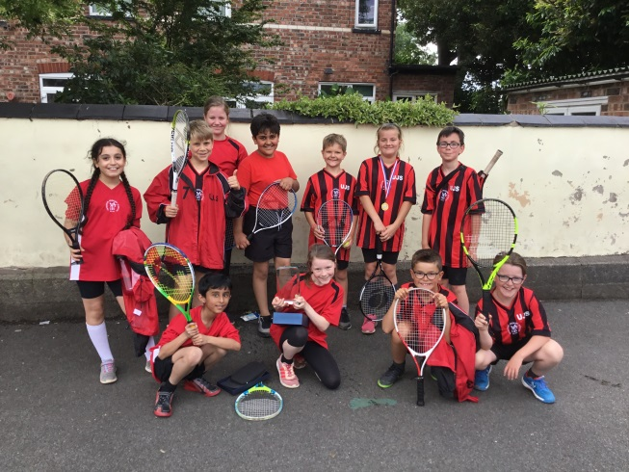

Playground Leaders

A number of Year 5 and 6 pupils were trained by Kay Statham (Flixton Girls School and Trafford School's Sports Co-ordinator) in Autumn 2018. These pupils would then train further pupils and I am pleased to say that upwards of 50 children have been involved in providing sports activities at lunch and break times, primarily to children in KS1.

There will be further training at the beginning of the new academic year, extending provision to all break times when some of these leaders will be available to be referees / umpires to sports activities on the playground !

Extra-Curricular Sports Involvement

Following the merger of previous Urmston Juniors and Urmston Infants to form Urmston Primary School in April 2017, we had set a target of 65% involvement of all pupils across the school in PE / Sports outside of the required PE lessons. Last year, the Juniors actually achieved an impressive 73% involvement so we decided to increase our target this year to 75%.

A survey of all classes in March produced the following results :

KS1 (Infants) : 113 out of 205 = 55%
KS2 (Juniors) : 123 out of 281 = 44%

Total of Primary School:
236 out of 486 = 48.6%

By the end of the Summer Term, the Juniors had achieved 64% extra-curricular involvement, which is creditable but a little disappointing given last year's figures. We will maintain a 75% target for next year and will strive to reach that !

This was an incredible achievement for the Juniors, especially given the DFE's figures for obesity in Greater Manchester pupils (25% of all children at end of KS1 are deemed to be obese, rising to 33% by KS2). The involvement and motivation of Junior pupils in sports activities will continue to receive increased attention, especially those children who admit to not enjoying physical activity.
We will continue to link physical activity into other curriculum areas with a greater focus in PHSE and the physical/mental/social benefits of sporting activity.

Extra-Curricular PE and Sports Activities

These are some of the clubs and coaching sessions that have been offered to KS1 and KS2 pupils in 2018-19 :

Football (separate training sessions for boys and girls)
Judo Fencing Netball
Cricket Tag rugby Cheerleading
Lacrosse Basketball Hockey
Boxing skills Archery Dodgeball
Tennis Frisbee Baseball
Gymnastics

Trafford School Sports Partnership 2018-19

UPS have registered for Tier 1 membership of this Partnership. Amongst many benefits, this provides membership of the Youth Sports Trust (YST), access to YST online resources, access to 5-a-Day Physical Activity online resource, entry into all Trafford SSP competitions, festivals and events, a Playground Leaders training course delivered on the school premises, access to the 2018-19 Healthy Active Lifestyles Challenge, Trafford SSP cross-curricular resources and initiatives etc.

PE Assessment

We have been able to use some of our Sports Premium to invest in PESH's computer-based assessment application - the PE Passport - which all staff have received training in and have begun to use to assess the outcomes of their PE lessons.

Sports Coaching and Staff Training

As with any organisation, there are varying levels of sporting interest and confidence amongst staff in UPS. We have used our main provider to train our staff, both in general competence and in specific sporting areas, during 2018-19 and intend to do likewise in the coming academic year.

Sporting Partnerships / Links to Local Sports Clubs and organisations

UPS has developed relationships with a number of local sports clubs during the year. These clubs have provided taster sessions for children (followed by invitations to their own club events and training in many cases) as well as enabling important training for members of staff.

These organisations include :

Lancashire County Cricket Club
Manchester United Football Club
Judo Education
Fencing Education
Beth Tweddle Gymnastics
Red Tiger Karate Club
Baseball Softball UK (North West)
Urmston Sports Club (Cricket and Tennis sections)

We intend to expand this number of partners in 2019-20!

Sports Coaching in Action !

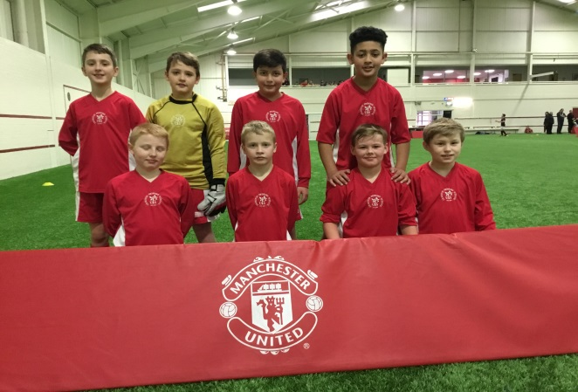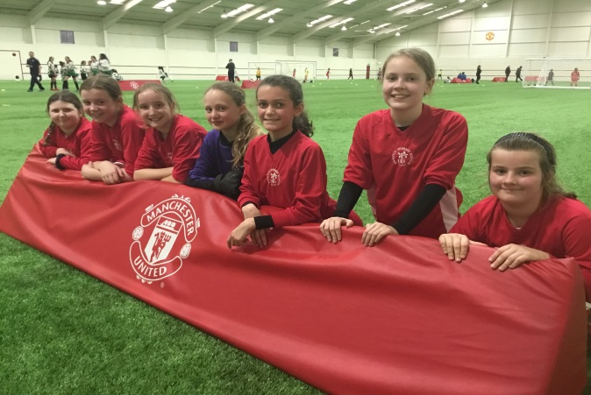
Boys and girls football squads at Manchester United Foundation 7-a-side football competition at The Cliff Training Ground.

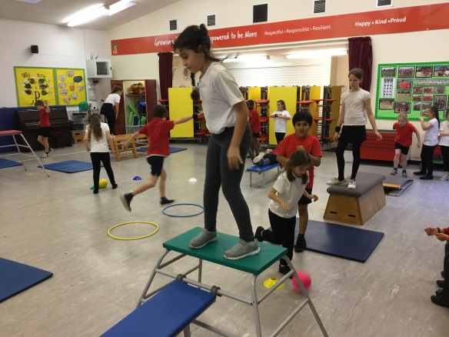
Gymnastics with Beth Tweddle's Gymnastics Group

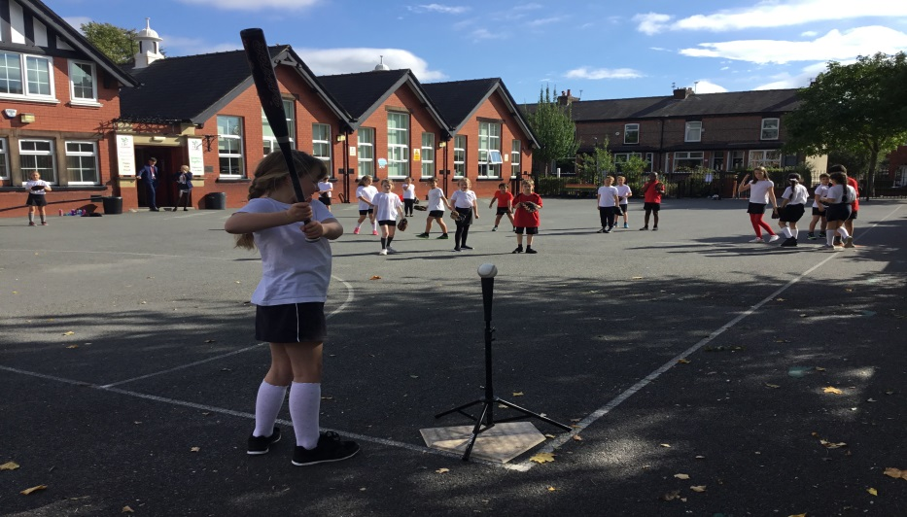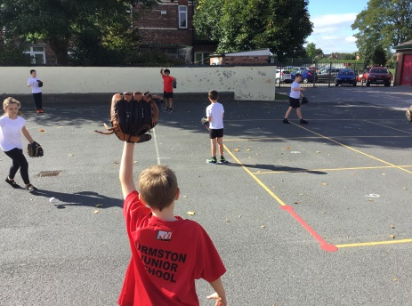
Baseball with Baseball Softball UK

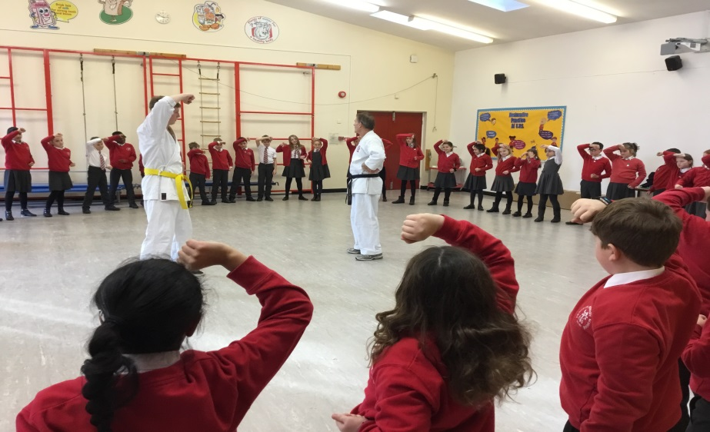
Year 5 Karate with Red Tiger Karate Club

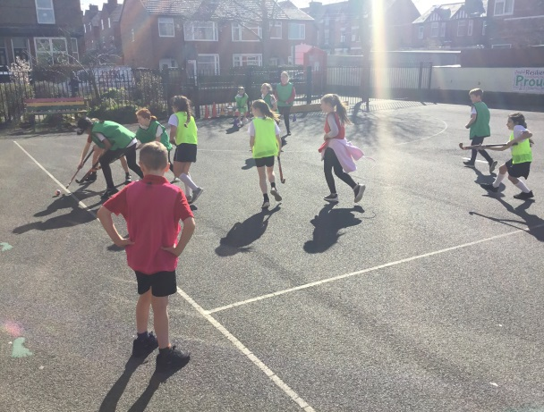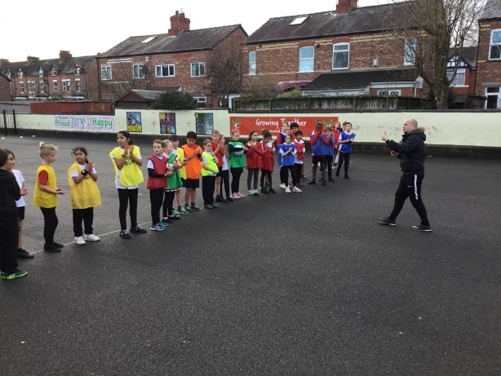
Hockey and Football coaching from PE Sports Hub

And, finally, some of our teams !

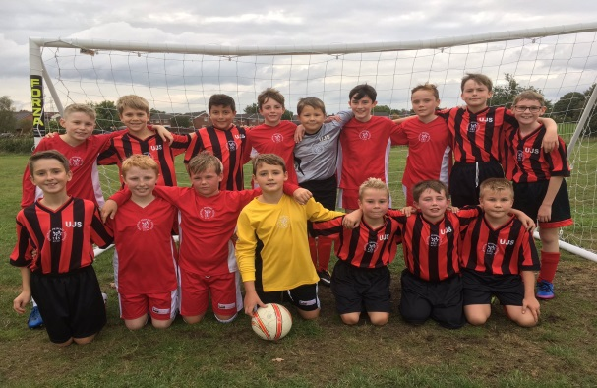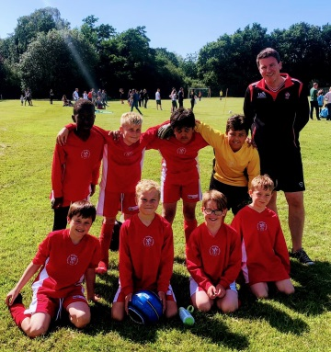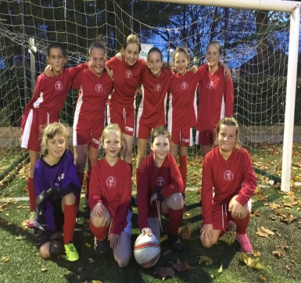

Football : Boys A.B & C teams ; girls' squad

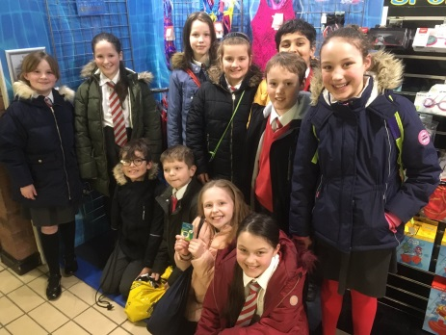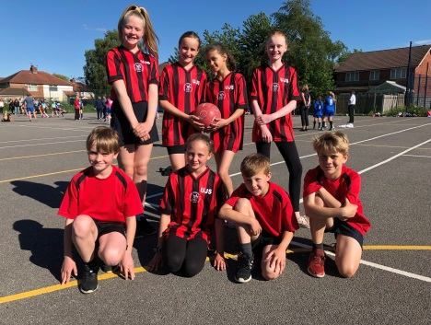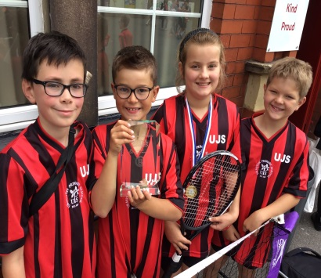

Swim squad ; Hi-5 netballers ; Tennis team

Report completed by
Andy Greenwood PE-Coordinator KS2 a.greenwood@urmstonprimaryschool.com

